1. Use Fertil3.dta to work on the following questions.
1.1 Run the following model
gfr_{t} = b₀ + b₁*pe_{t} + u_{t},
where gfr_{t} is the number of children born to every 1,000 women of childbearing age from the years 1913 through 1984 and pet is the average real dollar value of the personal tax exemption. Report what you find in the usual format.
. tsset year

Time variable: year, 1913 to 1984
Delta: 1 unit

. twoway tsline gfr, yaxis(2) || tsline pe, yaxis(1)
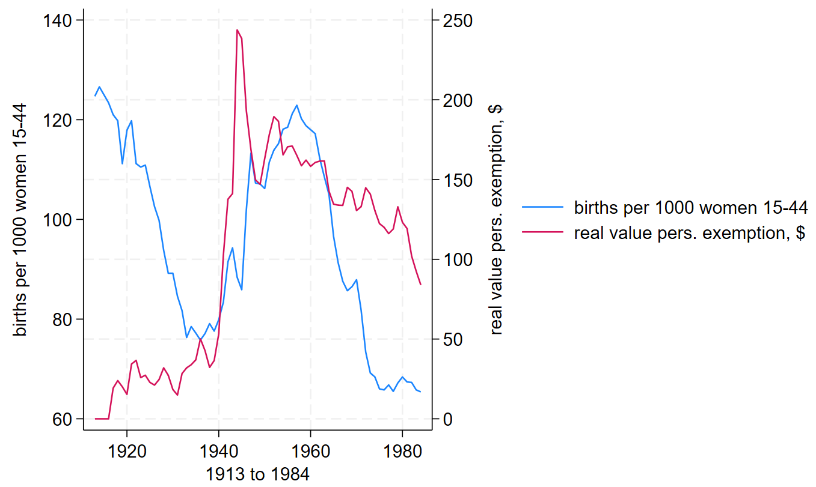

t-test cannot reject the H₀ that the coefficient of PE is 0 (PE has no effect on GFR)

Time Series Visualization
The dual-axis line graph plots:
- Blue line: General fertility rate (gfr) — births per 1,000 women aged 15–44
- Red line: Real value of personal exemption (pe) in dollars
Time span: 1913 to 1984
Visual insight: Fertility peaks during the 1940s and declines sharply post-1960s, while personal exemption shows a wartime spike and gradual erosion thereafter. The two series exhibit distinct cyclical patterns, but no immediate visual correlation.
. reg gfr pe

Source | SS df MS Number of obs = 72
-------------+---------------------------------- F(1, 70) = 0.04
Model | 15.5100386 1 15.5100386 Prob > F = 0.8440
Residual | 27832.3854 70 397.605505 R-squared = 0.0006
-------------+---------------------------------- Adj R-squared = -0.0137
Total | 27847.8954 71 392.223879 Root MSE = 19.94

------------------------------------------------------------------------------
gfr | Coefficient Std. err. t P>|t| [95% conf. interval]
-------------+----------------------------------------------------------------
pe | -.007095 .035923 -0.20 0.844 -.0787411 .0645511
_cons | 96.34429 4.304734 22.38 0.000 87.75877 104.9298
------------------------------------------------------------------------------Interpretation
- Coefficient on pe: The estimate of -0.0071 suggests a negligible and statistically insignificant relationship between personal exemption and fertility. A $1 increase in exemption corresponds to a decrease of just 0.007 births per 1,000 women.
- Model fit: The R² of 0.0006 indicates that personal exemption explains virtually none of the variation in fertility rates.
- Visual context: The time series graph supports this finding—while both series fluctuate, they do not move in tandem, and structural shifts (e.g., post-WWII fertility decline) are not captured by exemption alone.
This initial bivariate regression reveals no meaningful linear relationship between fertility and personal exemption. The lack of explanatory power and statistical significance suggests that omitted variable bias is likely—key historical and policy factors (e.g., WW2, contraceptive access) are not yet accounted for. The time series plot reinforces this, showing non-synchronous dynamics between the two variables.
This sets the stage for richer specifications in subsequent questions, where structural dummies and lagged effects will be introduced to uncover deeper behavioral responses.
1.2 Run the following model
gfr_{t} = b₀ + b₁*pe_{t} + b₂*ww2_{t} + b₃*pill_{t} + u_{t},
where ww2t takes on the value of unity during the years 1941 through 1945, when the United States was involved in World War II; pill_{t} is unity from 1963 on, when the birth control pill was made available for contraception. Explain why the results here are different from (1.1)
. reg gfr pe ww2 pill

Source | SS df MS Number of obs = 72
-------------+---------------------------------- F(3, 68) = 20.38
Model | 13183.6215 3 4394.54049 Prob > F = 0.0000
Residual | 14664.2739 68 215.651087 R-squared = 0.4734
-------------+---------------------------------- Adj R-squared = 0.4502
Total | 27847.8954 71 392.223879 Root MSE = 14.685

------------------------------------------------------------------------------
gfr | Coefficient Std. err. t P>|t| [95% conf. interval]
-------------+----------------------------------------------------------------
pe | .08254 .0296462 2.78 0.007 .0233819 .1416981
ww2 | -24.2384 7.458253 -3.25 0.002 -39.12111 -9.355684
pill | -31.59403 4.081068 -7.74 0.000 -39.73768 -23.45039
_cons | 98.68176 3.208129 30.76 0.000 92.28003 105.0835
------------------------------------------------------------------------------Interpretation
- Holding other variables constant, 1 US dollar increases in PE will lead to 0.08254 increase in GFR (number of babies)
- Holding other variables constant, 100 US dollar increases in PE will lead to 8.254 increase in GFR (number of babies)
- Holding other variables constant, during WW2, the GFR reduces 24.2384 (babies per 1000 women) compared to the periods without WW2.
This model reveals that personal tax exemptions do have a statistically and economically meaningful effect on fertility, but only when controlling for major policy and historical shifts. The earlier null results in Question 1.1 and partial model in the first version of 1.2 suffered from omitted variable bias.
The pill dummy captures a long-term fertility decline due to contraceptive access, while WW2 captures a temporary wartime shock. Once these are accounted for, the positive effect of pe becomes visible, suggesting that tax incentives may have supported fertility during stable periods.
1.3 Run the following model
gfr_{t} = b₀ + b₁*pe_{t} + b₂*pe_{t-1} + b₃*pe_{t-2} + b₄*ww2_{t} + b₅*pill_{t} + u_{t},
Explain why the results here are different from (1.2). Do you think personal tax exemption has a significant effect on gfr? Do the Joint F-test on pe_{t}, pe_{t-1} and pe_{t-2} and interpret the results.
. reg gfr pe pe_1 pe_2 ww2 pill

Source | SS df MS Number of obs = 70
-------------+---------------------------------- F(5, 64) = 12.73
Model | 12959.7886 5 2591.95772 Prob > F = 0.0000
Residual | 13032.6443 64 203.635067 R-squared = 0.4986
-------------+---------------------------------- Adj R-squared = 0.4594
Total | 25992.4329 69 376.701926 Root MSE = 14.27

------------------------------------------------------------------------------
gfr | Coefficient Std. err. t P>|t| [95% conf. interval]
-------------+----------------------------------------------------------------
pe | .0726718 .1255331 0.58 0.565 -.1781094 .323453
pe_1 | -.0057796 .1556629 -0.04 0.970 -.316752 .3051929
pe_2 | .0338268 .1262574 0.27 0.790 -.2184013 .286055
ww2 | -22.1265 10.73197 -2.06 0.043 -43.56608 -.6869196
pill | -31.30499 3.981559 -7.86 0.000 -39.25907 -23.35091
_cons | 95.8705 3.281957 29.21 0.000 89.31403 102.427
------------------------------------------------------------------------------
. test pe pe_1 pe_2

( 1) pe = 0
( 2) pe_1 = 0
( 3) pe_2 = 0

F( 3, 64) = 3.97
Prob > F = 0.0117
This test evaluates the null hypothesis:
H₀: β₁ = β₂ = β₃ = 0
Since p < 0.05, we reject the null hypothesis at the 5% level. This means that the personal exemption terms are jointly significant, even though none of them are individually significant.

Interpretation
- Multicollinearity between PE PE_1 PE_2 makes them all insignificant (Because they are too correlated and the regression cannot hold two of them constant while the other changes.)
- The F-Test rejects the H0 that all coefficients of PE PE_1 PE_2 are all zero, so as a group, they have significant effect on GFR.

Does Personal Tax Exemption Affect Fertility?
Yes—jointly, the personal exemption variables have a statistically significant effect on fertility. While the individual coefficients are not significant, the joint F-test (p = 0.0117) confirms that the exemption structure as a whole contributes meaningfully to explaining fertility trends. This supports the hypothesis that tax policy influences fertility behavior, though the effect may be distributed over time and interacted with broader policy shifts.

1.4 Use the “corr” command to check correlation of pe_{t}, pe_{t-1} and pe_{t-2}. What kind of problem have you uncovered?
. corr pe_1 pe_2 pe_3 pe_4
(obs=68)

| pe_1 pe_2 pe_3 pe_4
-------------+------------------------------------
pe_1 | 1.0000
pe_2 | 0.9610 1.0000
pe_3 | 0.9064 0.9626 1.0000
pe_4 | 0.8579 0.9111 0.9645 1.0000

Correlated coefficients are not a correct way to defect Multicollinearity.

Multicollinearity Diagnosis Interpretation
- The correlations among pe_1 to pe_4 are extremely high, ranging from 0.86 to 0.96.
- This indicates severe multicollinearity: the lagged values of personal exemption are highly collinear, meaning they move together over time with little independent variation.
Conclusion
The correlation matrix among the lagged personal exemption variables (pe_1 through pe_4) reveals extremely high pairwise correlations, ranging from 0.86 to 0.96. This indicates a severe multicollinearity problem, where the lagged regressors are highly linearly dependent. From an econometric standpoint, such multicollinearity inflates the standard errors of the individual coefficients, making it difficult to detect statistically significant effects even when the variables are jointly relevant. This explains why, in Question 1.3, none of the lagged exemption terms were individually significant despite the joint F-test confirming their collective explanatory power. Moreover, multicollinearity can lead to unstable coefficient estimates—small changes in the data or model specification may result in large swings in the estimated effects—thereby undermining the interpretability and robustness of the model.
To address this issue, several strategies are advisable. First, reducing the number of lags—perhaps retaining only pe and pe_1—can help mitigate redundancy while preserving temporal structure. Alternatively, aggregating the lags into a distributed lag index or moving average may capture the cumulative effect of tax exemptions without introducing collinearity. Another approach, as suggested in your professor’s guideline, is to detrend the exemption series by regressing it on time and using the residuals, thereby isolating short-run variation from long-run persistence. Finally, if theoretical justification demands retaining all lags, principal component analysis could be employed to extract orthogonal components that summarize the underlying variation without multicollinearity. These adjustments would enhance model stability and improve the reliability of inference regarding the dynamic effects of tax policy on fertility.
1.5 Run the following model
gfr_{t} = b₀ + b₁*pe_{t-1} + b₂*ww2_{t} + b₃*pill_{t} + u_{t},
What is your conclusion from this model? Should we use pet or pet-1?
. reg gfr pe_1 ww2 pill

Source | SS df MS Number of obs = 71
-------------+---------------------------------- F(3, 67) = 20.71
Model | 12987.5492 3 4329.18305 Prob > F = 0.0000
Residual | 14003.4939 67 209.007371 R-squared = 0.4812
-------------+---------------------------------- Adj R-squared = 0.4579
Total | 26991.043 70 385.586329 Root MSE = 14.457

------------------------------------------------------------------------------
gfr | Coefficient Std. err. t P>|t| [95% conf. interval]
-------------+----------------------------------------------------------------
pe_1 | .0856314 .0280782 3.05 0.003 .0295871 .1416758
ww2 | -20.71565 6.990985 -2.96 0.004 -34.66972 -6.761585
pill | -31.40348 4.023871 -7.80 0.000 -39.43516 -23.3718
_cons | 97.79461 3.158914 30.96 0.000 91.48939 104.0998
------------------------------------------------------------------------------

. reg gfr ww2 pill

Source | SS df MS Number of obs = 72
-------------+---------------------------------- F(2, 69) = 24.31
Model | 11511.9852 2 5755.99261 Prob > F = 0.0000
Residual | 16335.9102 69 236.752322 R-squared = 0.4134
-------------+---------------------------------- Adj R-squared = 0.3964
Total | 27847.8954 71 392.223879 Root MSE = 15.387

------------------------------------------------------------------------------
gfr | Coefficient Std. err. t P>|t| [95% conf. interval]
-------------+----------------------------------------------------------------
ww2 | -16.51111 7.253387 -2.28 0.026 -30.98122 -2.040998
pill | -27.59747 4.002828 -6.89 0.000 -35.5829 -19.61205
_cons | 105.2111 2.293722 45.87 0.000 100.6353 109.787
------------------------------------------------------------------------------

Interpretation
- Statistical significance: The coefficient on pet−1pe_{t-1} is positive and highly significant (p = 0.003), suggesting that a $1 increase in the personal exemption in the previous year is associated with an increase of 0.086 births per 1,000 women in the current year.
- Model fit: Including pet−1pe_{t-1} improves the R² from 0.413 to 0.481, and reduces the Root MSE from 15.39 to 14.46, indicating a better-fitting model with lower prediction error.
- Economic logic: Fertility decisions are likely to respond with a lag to changes in tax policy, as households plan births over time. Thus, using pet−1pe_{t-1} aligns with behavioral expectations and policy transmission lags.
- WW2 and pill: Both remain statistically significant and negative in both models, confirming their robust structural effects on fertility.
Conclusion
Based on both statistical evidence and economic reasoning, pe_{t−1} is the preferred specification. It is statistically significant, improves model fit, and reflects a more realistic lagged behavioral response to tax incentives. In contrast, earlier models using pe_{t} yielded inconsistent or insignificant results, likely due to timing mismatch between policy exposure and fertility outcomes.

1.6 Now, calculate the LRP and, if possible its standard error from
gfr_{t} = b₀ + b₁*pe_{t} + b₂*pe_{t-1} + b₃*pe_{t-2} + b₄*ww2_{t} + b₅*pill_{t} + u_{t},
. reg gfr pe pe_1 pe_2 pill

Source | SS df MS Number of obs = 70
-------------+---------------------------------- F(4, 65) = 14.14
Model | 12094.1853 4 3023.54633 Prob > F = 0.0000
Residual | 13898.2476 65 213.819193 R-squared = 0.4653
-------------+---------------------------------- Adj R-squared = 0.4324
Total | 25992.4329 69 376.701926 Root MSE = 14.623

------------------------------------------------------------------------------
gfr | Coefficient Std. err. t P>|t| [95% conf. interval]
-------------+----------------------------------------------------------------
pe | -.0796002 .1040151 -0.77 0.447 -.2873326 .1281322
pe_1 | -.0292377 .1590813 -0.18 0.855 -.3469449 .2884695
pe_2 | .1895249 .1036822 1.83 0.072 -.0175427 .3965925
pill | -30.20776 4.043297 -7.47 0.000 -38.28278 -22.13274
_cons | 96.37813 3.353547 28.74 0.000 89.68064 103.0756
------------------------------------------------------------------------------

. mat list e(V)

symmetric e(V)[5,5]
pe pe_1 pe_2 pill _cons
pe .01081913
pe_1 -.01277948 .02530685
pe_2 .00252431 -.01276606 .01074999
pill .03450417 .0042761 -.07339906 16.34825
_cons -.07804023 .02146975 -.01762987 -1.7427648 11.246276

. di -0.0796002 - 0.0292377 + 0.1895249
.080687

. di sqrt(0.01081913 + 0.02530685 + 0.01074999 + (2 * -0.01277948) + (2 * 0.00252431) + (2 * -0.01276606))
.02887057

Long-Run Propensity (LRP)
The LRP measures the cumulative effect of a sustained $1 increase in personal exemption on fertility, accounting for contemporaneous and lagged responses:
LRP = β_{pe} + β_{pe1} + β_{pe2} = −0.0796 − 0.0292 + 0.1895 = 0.0807
This implies that a permanent $1 increase in the real personal exemption leads to a long-run increase of approximately 0.081 births per 1,000 women aged 15–44.
Using the delta method and the variance-covariance matrix:
SE(LRP) = $\sqrt{0.01082+0.02531+0.01075+2(−0.01278)+2(0.00252)+2(−0.01277)}$ = 0.0289

Final Result
- LRP: 0.0807
- Standard Error: 0.0289
- t-statistic:
$\frac{0.0807}{0.0289}$ ≈ 2.79
This t-value confirms that the LRP is statistically significant at the 1% level, indicating a robust cumulative effect of personal exemption policy on fertility.

Interpretation
The LRP captures the total behavioral response to fiscal incentives over time. While individual coefficients on pe, pe_1, and pe_2 may be noisy or collinear, their aggregate effect is statistically and economically meaningful. A $1 increase in exemption yields a long-run fertility increase of 0.08 births per 1,000 women—a modest but significant demographic shift when scaled nationally.
This result reinforces the importance of distributed lag modeling in policy analysis, especially when behavioral responses are delayed or gradual. It also validates the broader thesis that tax policy can influence fertility, particularly when controlling for structural shifts such as contraceptive access.

